Inventory of Historic Resource - Property Acquisition (B. Henderson)
Potential Acquisition of the Marshall McLuhan Residence

Recommendation:
That the January 11, 2012, Sustainable Development report 2012SPE002 be received for information.
Report Summary
This report responds to an Administrative Inquiry on the potential acquisition of the Marshall McLuhan Residence by the City for rental to a not-for-profit organization/use.
Previous Council/Committee Action
At the August 31, 2011, City Council meeting the follow Councillor Inquiry was made:
Edmonton is a city where ideas are born and creativity has and will flourish.
One hundred years ago this year, a leading 20th century thinker was born in Edmonton. His early years significantly influenced the long-term philosophical theories he held which shaped the international community. Marshall McLuhan, the man behind “the medium is the message” was a westerner born in Edmonton with deep family roots in the Edmonton region – roots that he maintained and nurtured all of his life.
There now exists an opportunity to acquire for the City of Edmonton to acquire a piece of city history, the birth place of Marshall McLuhan in the Highlands. A desire has been voiced by the community who believe that this property can be repurposed from a private residence into a contemplative creative working space for our creative community.
Can Administration please outline and report back to Executive Committee on the following:
- What is the significance of the McLuhan House to Edmonton’s historic character?
- Can the McLuhan House be added to our Inventory of Historic Resources to recognize Marshall McLuhan’s significance to the City of Edmonton.
- What is the viability of purchasing this property and bringing into the City inventory for use as rental not-for-profit use?
- How can the Edmonton Art Council program the space to support our creative community and support their needs?
- Are their partners that may exist who would have an interest in supporting the purchase or operations of the space should it be added to the City inventory?
Report
Administration consulted with the Edmonton Arts Council to respond to this inquiry.
Historic Significance of McLuhan Residence
The Marshall McLuhan Residence is located at 11342 - 64 Street NW, and occupies one and a half lots in the historic Highlands neighbourhood. The integrity of the house is high and the style is fairly typical of residences developed prior to World War I in Edmonton’s earliest neighbourhoods (see Attachment 1).
The house is significant for having been the early boyhood home of Marshall McLuhan. The McLuhan family moved into the house in 1912 when Marshall was one year old and relocated to Winnipeg by 1915. Despite moving away as a young boy, McLuhan maintained a very strong connection with Edmonton and returned often.
The house is known in the Highlands neighbourhood as the Marshall McLuhan Residence and is included in “The Highlands Historical Walking Tour” booklet. The current owners have occasionally allowed access to the residence by visitors seeking to connect with an extraordinary Canadian and leading thinker on the global impact of mass media.
Eligibility as a Historic Resource
The Marshall McLuhan Residence was added to the Inventory of Historic Resources in Edmonton in 1993, in large part to acknowledge McLuhan’s accomplishments and connection to the Highland’s neighbourhood and Edmonton.
Sustainable Development would support the designation of the building as a Municipal Historic Resource.
Viability if City Purchase for Re-Use by Non-Profit
The current owner of the McLuhan Residence is willing to sell the property to the City at market value. However, no identified funding source currently exists by which to acquire the property.
Council approved “Non-Profit Leasing Guidelines” provide that City property may be leased to qualified non-profits at $1 plus all operating and maintenance costs. Should the City acquire the property, the Edmonton Arts Council would agree to lease the property under the terms of the Guidelines and manage the property for use by non-profits.
Re-Use
In consultation with potential partners, the Edmonton Arts Council suggested the residence would be re-purposed as follows:
Main Floor: the front room could be an interpretative space to provide a narrative about Marshall McLuhan, his connection to Edmonton and his place in history and culture. This would be developed and maintained in partnership with the University of Alberta. Associated with the interpretive space would be the secondary space for a library and area for limited public events including readings and meetings. The remaining small room on the main floor would be used as an office for either a writer or writer-in-residence.
Second Floor: could be used as offices plus a residential suite for visiting scholars or artists. The Festival of Ideas has indicated an interest in the office space as well as access to the residential suite.
Basement: with two finished rooms and a large general room, this could also be used for offices, a residential suite, and/or general storage.
Outbuilding: could be used as an artist studio, a meeting room or possibly as a display room for interpretive purposes.
The property also has sufficient room to park four vehicles.
The current land use zoning for the property is Single Family Detached (RF1) and does not allow for the suggested possible uses identified above. However, if the property is designated as a Municipal Historic Resource it would be rezoned to a Direct Control Provision as per standard practice to protect its historic integrity and to provide flexibility in its re-use.
Potential Partners to Share in the Purchase and Operation
As yet no group has stepped forward as a potential partner in sharing the purchase cost.
The Edmonton Arts Council indicates interest by non-profits in using the McLuhan Residence is very strong. Accordingly, the Council has developed a business model to manage the residence in partnership with the University Faculty of Arts - Festival of Ideas and the Writer’s Guild of Alberta (see Attachments 2 and 3). The Highlands Historical Society and the Highlands Community League of offered their support for the concept. (see Attachments 4 and 5). The Council estimates it could obtain $2,200 per month in rent from its partners, which would fund the operating expenses and create a contingency to manage vacancies and ongoing maintenance of the property.
Potential Next Steps
Should Executive Committee wish to pursue the purchase of the property and its lease to the Edmonton Arts Council, then the following steps could be pursued:
- Recommend to Council that Administration advance the purchase through the supplemental budget adjustment.
- Acquire the property.
- Designate the residence as a Municipal Historic Resource and rezone the property to a Direct Control Provision to protect the structure and accommodate the flexibility of uses necessary to accommodate the Edmonton Arts Council proposed model.
- Enter in an lease agreement with Edmonton Arts Council.
Policy
This report relates to City Policy C450B, Policy to Encourage the Designation and Rehabilitation of Historic Resources in Edmonton.
Corporate Outcomes
This report supports The Way Ahead - Edmonton’s Strategic Plan 2009-2018:
- Improve Edmonton’s Liveability-Preserve, celebrate and support Edmonton’s heritage, arts and culture.
Budget/Financial Implications
Property acquisitions are normally dealt with through the capital priorities process. While the potential purchase of the McLuhan Residence was not included in the 2012-14 Capital Budget, funding could be secured through the Supplementary Budget Adjustment process.
Attachments
- Photo of the Marshall McLuhan Residence
- Letter of Support- University of Alberta – Festival of Ideas
- Letter of Support - Writers Guild of Alberta
- Letter of Support from the Highlands Historical Society
- Letter of Support - Highlands Community League
Others Reviewing this Report
- L. Rosen, Chief Financial Officer and Treasurer
- L. Cochrane, General Manager, Community Services
- E.H. Edey, General Manager, Corporate Services

Photo of the Marshall McLuhan Residence

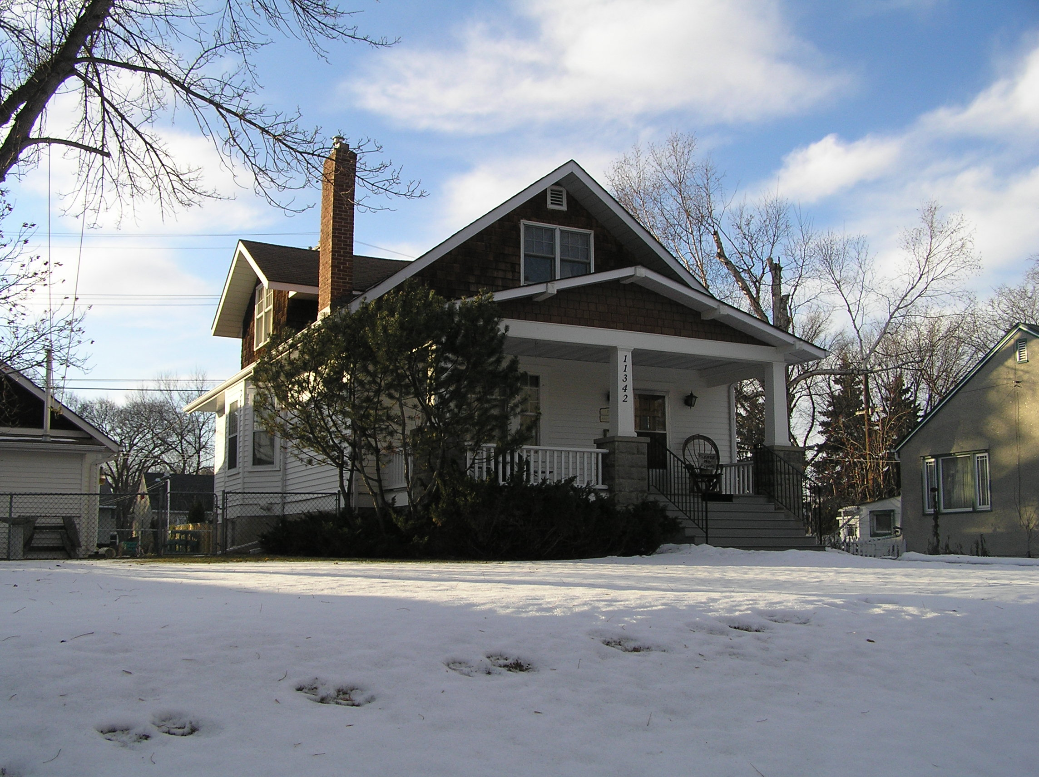

Letter of Support – University of Alberta – Festival of Ideas

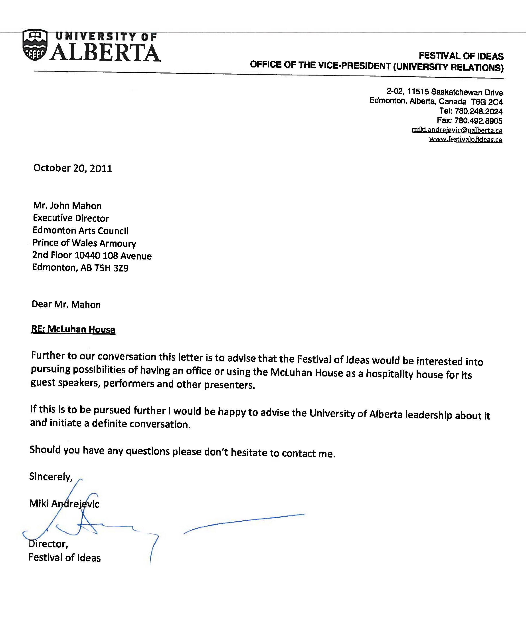

Letter of Support – Writers Guild of Alberta

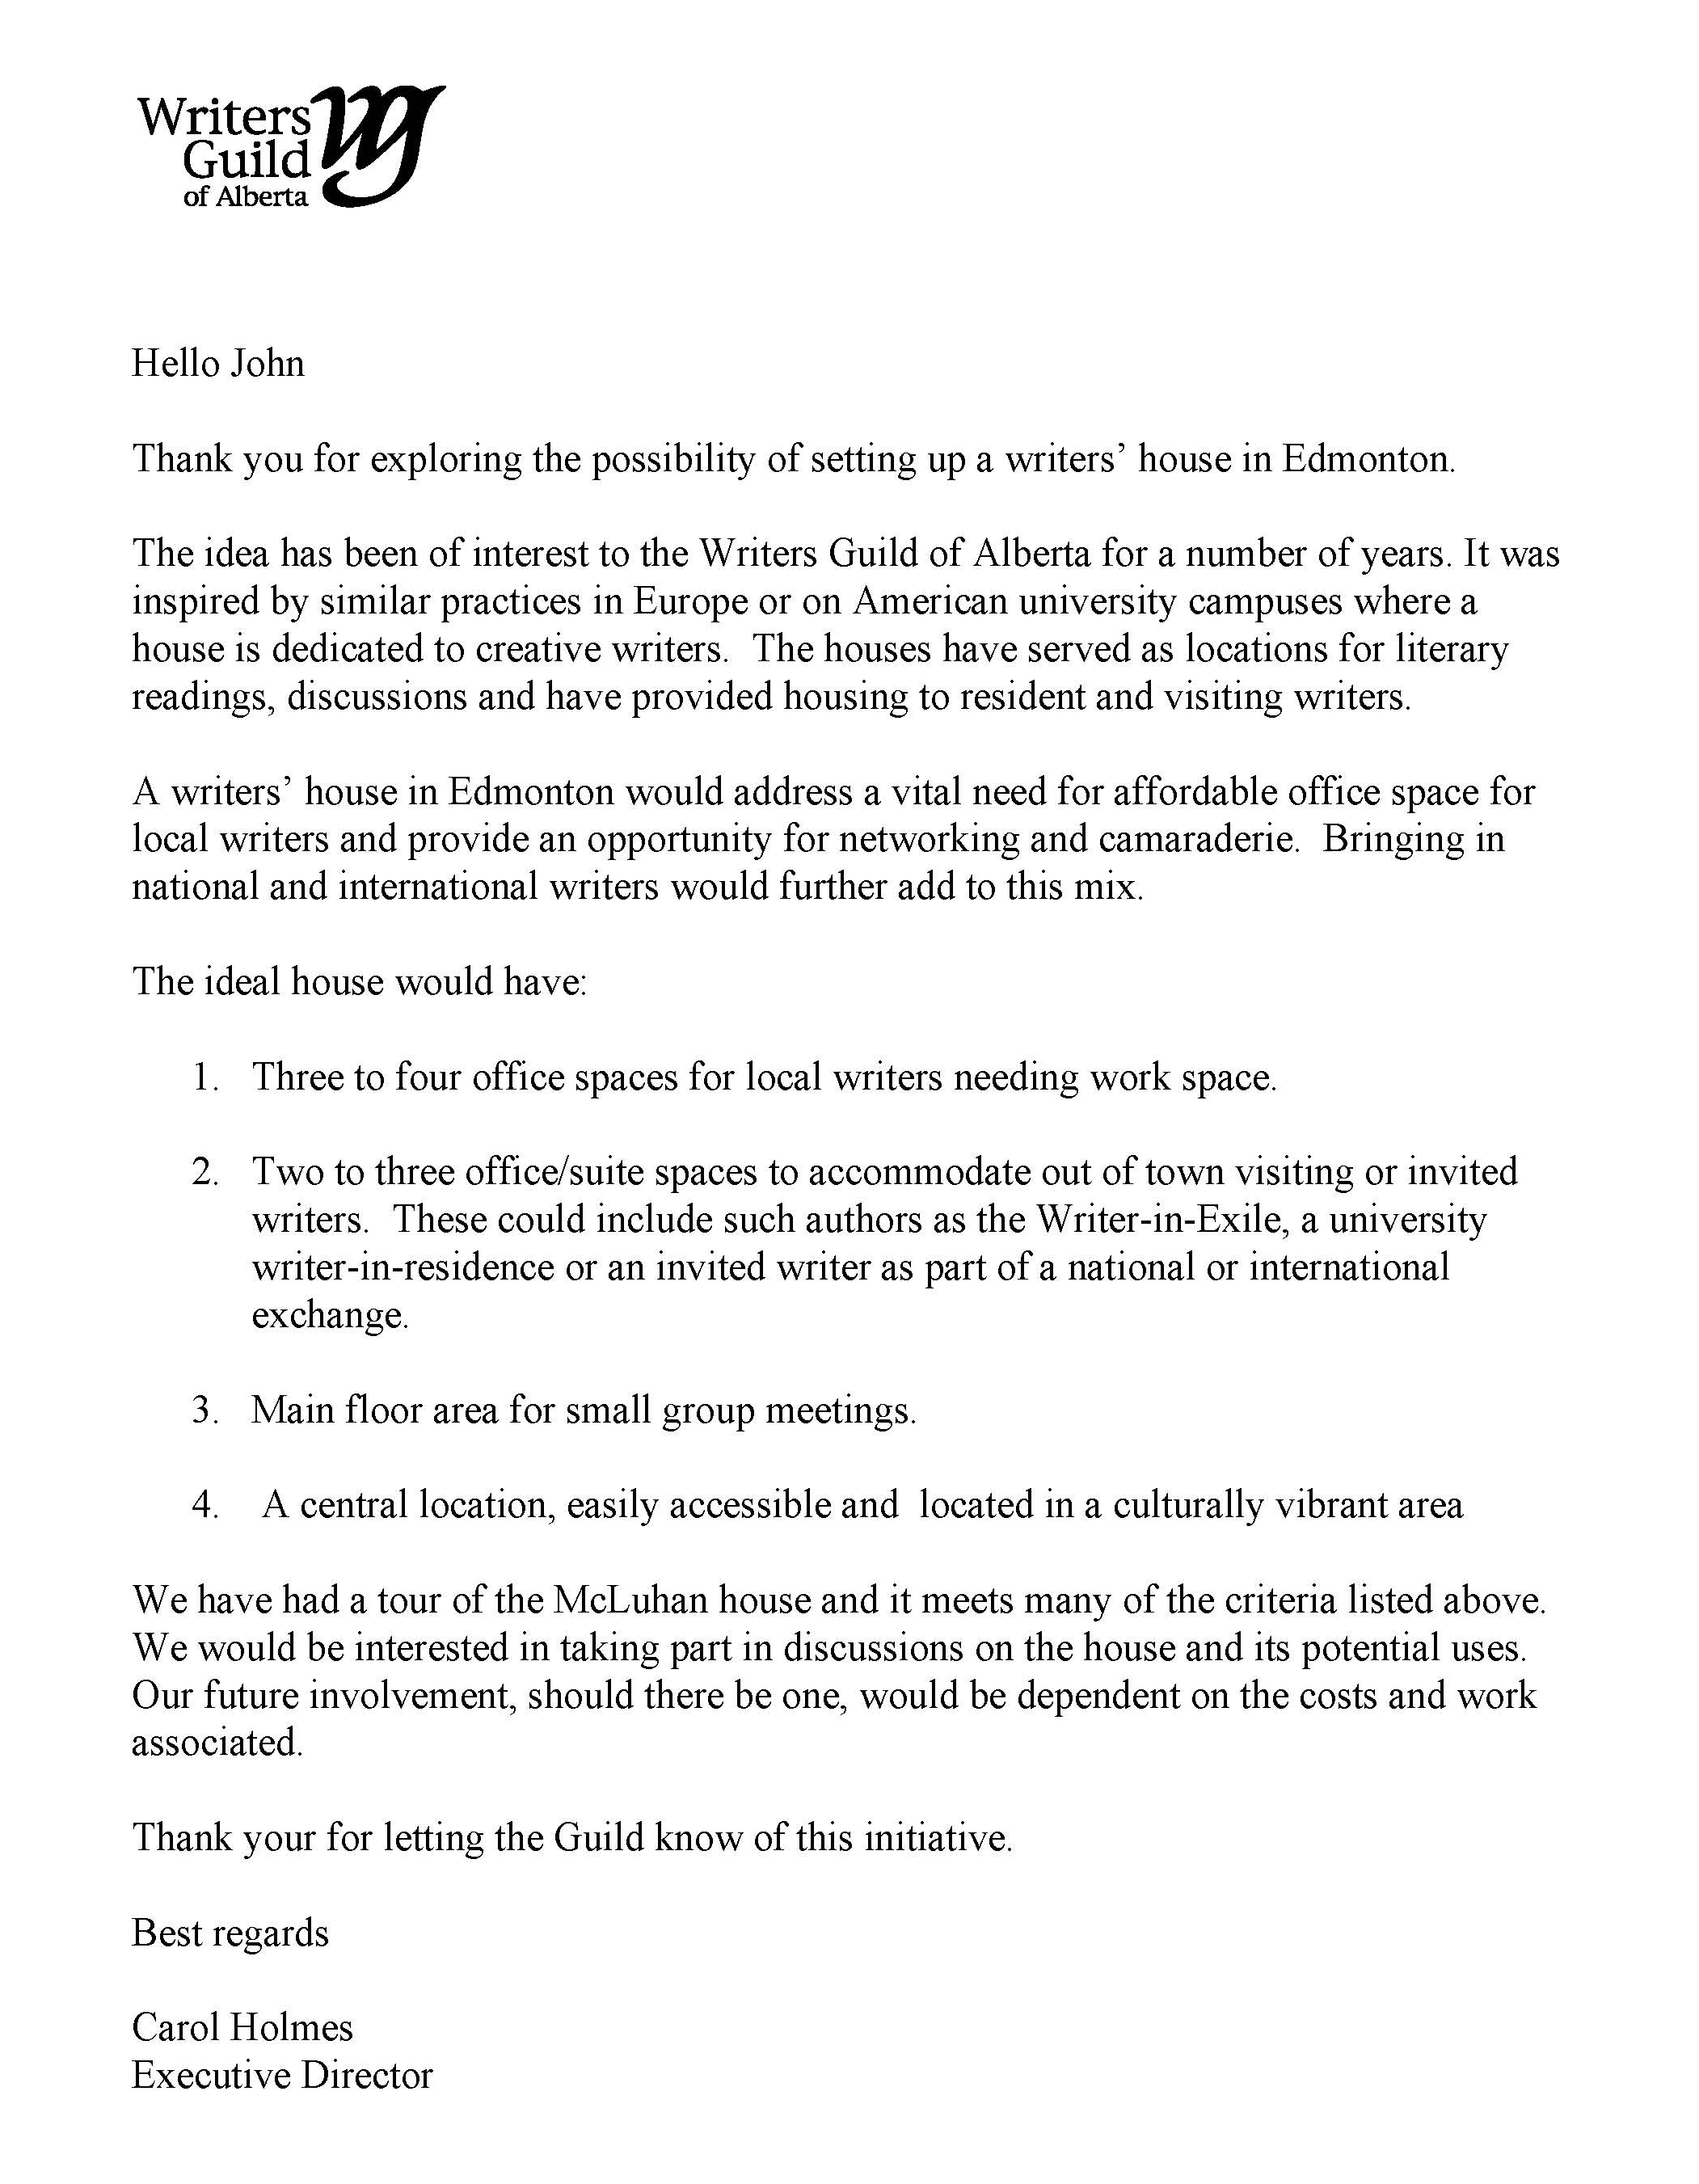

Letter of Support – Highlands Historical Society

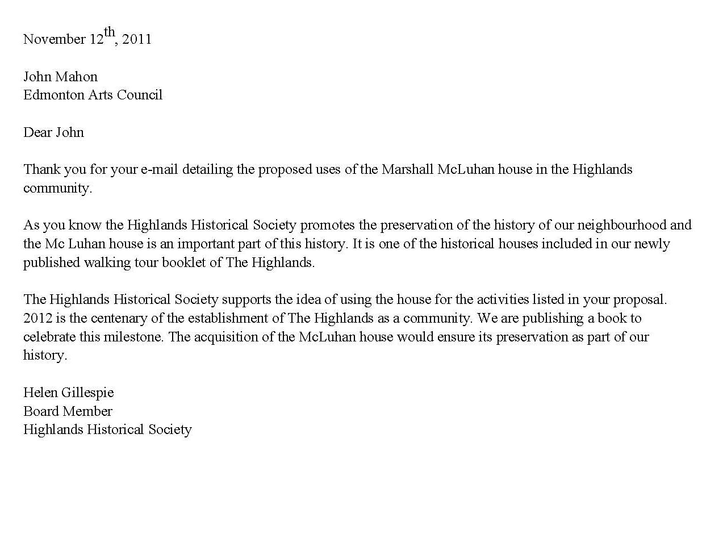

Letter of Support – Highlands Community League
